Upgrade ASM

Contents

Adjust Oracle Inventory Location -- oraInst.loc file 1

Unset Environment Variables 4

Execute runcluvfy.sh and resolve issues 4

run fixup file generated by previous command 4

Execute orachk and resolve issues 4

Check crs release and software versions. These should be 11.2.0.3.0 5

Create pw file in $ORACLE_HOME/dbs 5

Create ASMSNMP User 5

Check and upgrade Opatch version 5

Verify OPatch version 5

Upgrade OPatch 5

Adjust kernel parameter net.ipv4.ip_local_port_range 6

Edit file /etc/sysctl.conf 6

Enable the sysctl kernel parameters with sysctl. 6

Validate Oracle Inventory 8

Modify the response file 8

Install ASM Grid Infrastructure 8

Run root.sh 8

Shutdown all Databases and ASM 8

Install 11.2.0.4 Oracle ASM/GI Patch Set 9

Configure response file for software only install 9

Create new oracle home /opt/oraasm/product/11.2.0.4 9

Configure the CSS & OHAS services 9

Configure AUTO_START 10

Restart the OHAS stack 10

Check the CSS & OHAS state 11

Copy Old spfile to new GI Home 12

Create pfile from spfile 12

$> export ORACLE_SID=+ASM 12

Add ASM instance to cluster registry 13

Enable ASM instance Auto Start 13

Make sure the disks are discovered by kfod 13

Startup the ASM instance 13

Validate that the original diskgroup(s) were mounted 14

Validate the OHAS (autostart) services 14

Check the new HAS version 16

Should be 11.2.0.4 16

Modify /home/oraasm/asm.env 16

Apply PSU 11.2.0.4.5 to ASM 16

Upgrade OPatch 16

Create OCM response file 17

Execute emocmrsp 17

Validate Oracle Inventory 17

Apply PSU 11.2.0.4.5 to ASM 18

Check the GI (OCW Oracle Clusterware) version for PSU 11.2.0.4.5 18

Upgrade Database 11.2.0.3 to 11.2.0.4.5 18

Adjust oraInst.ora file 19

Refresh old pfile initNGHTSTBQ.env from spfile 19

Install 11.2.0.4 Database software into new folder 20

Adjust inventory location 20

Change owner of stage directory 20

Check software stage 20

**Edit response file** 21

Create inventory and Oracle home directories 22

Install Oracle in silent mode 22

Run root.sh 22

Set-up environment file 23

Copy pfile to new $ORACLE_HOME/dbs directory. 25

Copy listener.ora and tnsnames.ora to new $ORACLE_HOME/network/admin directory. 25

Apply Oracle Patch Set Update 11.2.0.4.5 25

**Location of Oracle Binaries on Data Domain** 25

**Backup Oracle inventory** 25

Check and upgrade Opatch version 26

Verify OPatch version 26

Check patch prerequisites 26

Apply the PSU (Patch Set Update) 27

Apply the One Off Patch 30

**\*\*\*\*\*\*\*\*\*\*\*\*\*\*\*\*\*\*\* From Jason \*\*\*\*\*\*\*\*\*\*\*\*\*\*\*\*\*\*\*\*\*\*\*\*\*\*\*\*\*\*** 31

**Apply One off patch to RDBMS for ORA-600 Errors on top of PSU 11.2.0.4.5** 31

**\*\*\*\*\*\*\*\*\*\*\*\*\*\*\*\*\*\*\* From Jason \*\*\*\*\*\*\*\*\*\*\*\*\*\*\*\*\*\*\*\*\*\*\*\*\*\*\*\*\*\*** 31

Upgrade Database 31

Execute database upgrade 31

2.5.2 Loading Modified SQL Files into the Database 32

Check PSU registration 32

Move new environment file into place. 32

Start Listener 32

Upgrade RMAN catalog 33

Backup Catalog Database 33

Execute RMAN catalog upgrade 34

Remove Old "11.2.0.3" Oracle Home 34

*Adjust /etc/oraInst.loc* 34

*Detach Old Oracle Home (11.2.0.3)* 35

*Make sure there are no files open at /opt/oranghtstbq/product/11.2.0.3* 35

*Remove Directory /opt/oranghtstbq/product/11.2.0.3* 35

# Adjust Oracle Inventory Location -- oraInst.loc file

Change /etc/oraInst.loc to point to /opt/oraasm/oraInventory

As root

# vi /etc/oraInst.loc

Before

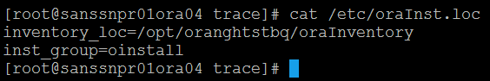

After

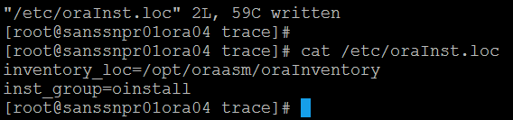

# Unset Environment Variables

As oraasm

$> unset ORACLE_BASE

$> unset ORACLE_HOME

$> unset ORACLE_SID

# Execute runcluvfy.sh and resolve issues

$> cd /data/backup/oracle/stage/11.2.0.4/grid

$> ./runcluvfy.sh stage -pre hacfg -fixup -fixupdir /tmp/fixup



## run fixup file generated by previous command

As root

$> /tmp/CVU_11.2.0.4.0_oraasm/runfixup.sh

# Execute orachk and resolve issues

As oraasm

$> /data/backup/oracle/stage/orachk/orachk -u -o pre

# Check crs release and software versions. These should be 11.2.0.3.0

+ASM > crsctl query has releaseversion

Oracle High Availability Services release version on the local node is [11.2.0.3.0]

+ASM > crsctl query has softwareversion

Oracle High Availability Services version on the local node is [11.2.0.3.0]

# Create pw file in $ORACLE_HOME/dbs

The ASMSNMP user is required to be a password file user for 11.2.x.x upgrades. Should this user not exist in the password file, the ASM upgrade will hang

$> orapwd file=orapw+ASM.ora

Note: I had trouble starting the Old ASM database with an orapw file. I linked orapw to orapw+ASM.ora, because I think it has trouble with the "+". The link seems to work.

$> ln -s orapw+ASM.ora orapw

Log into ASM database with sqlplus as sysasm and create the ASMSNMP user.

# Create ASMSNMP User

$> sqlplus / as sysasm

SQL> create user ASMSNMP identified by sys_gr1d;

SQL> grant sysasm to ASMSNMP;

# Check and upgrade Opatch version

## Verify OPatch version

OPatch version should be at least 11.2.0.3.6

/opt/oraasm/product/11.2.0.3 - +ASM > export PATH=$ORACLE_HOME/OPatch:$PATH

/opt/oraasm/product/11.2.0.3 - +ASM > opatch version

OPatch Version: 11.2.0.1.7

OPatch succeeded.

/opt/oraasm/product/11.2.0.3 - +ASM >

## Upgrade OPatch

As root

$> cd $ORACLE_HOME

$> mv OPatch OPatch.bak

$> cp /data/backup/oracle/stage/p6880880_112036_Linux-x86-64.zip .

$> unzip p6880880_112036_Linux-x86-64.zip

Archive: p6880880_112036_Linux-x86-64.zip

creating: OPatch/

creating: OPatch/jlib/

inflating: OPatch/jlib/oracle.opatch.classpath.jar

inflating: OPatch/jlib/oracle.opatch.classpath.windows.jar

inflating: OPatch/jlib/opatch.jar

$> chown -R oraasm:oinstall OPatch

# Adjust kernel parameter net.ipv4.ip_local_port_range

Starting with Oracle Clusterware 11gR1, ip_local_port_range should be between 9000 (minimum) and 65500 (maximum).

## Edit file /etc/sysctl.conf

As root

Modify entry net.ipv4.ip_local_port_range as follows.

net.ipv4.ip_local_port_range = 9000 65500

## Enable the sysctl kernel parameters with sysctl.

$> sysctl –p

**Still got this when installing the DB:**

*Hard Limit: maximum open file descriptors: This is a prerequisite condition to test whether the hard limit for "maximum open file descriptors" is set to at least 65536.*

*Soft Limit: maximum open file descriptors: This is a prerequisite condition to test whether the soft limit for "maximum open file descriptors" is set to at least 1024.*

*Hard Limit: maximum user processes: This is a prerequisite condition to test whether the hard limit for "maximum user processes" is set to at least 16384.*

*Soft Limit: maximum user processes: This is a prerequisite condition to test whether the soft limit for* running RAC so have *"maximum user processes" is set to at least 2047.*

OS parameter vm.swappiness is NOT set to the recommended value

We do not have issues with node eviction. Leave swappiness as is.

Package cvuqdisk-1.0.9-1-x86_64 is recommended but NOT installed

This package is not required, but would be nice to have for future troubleshooting.

Shell limit soft nproc for DB is NOT configured according to recommendation

Lets set this. Is this a sysadmin job or shall we set it? I am setting for this install. It looks like this is set by Bladelogic / GIT so my changes may be overwritten. This should be changed in BL/GIT.

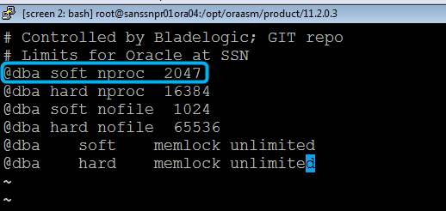

This recommendation represents a change or deviation from the documented values and should be considered a temporary measure until the code addresses the problem in a more permanent way.

Problem Statement:

------------------

The soft limit of nproc is not adjusted at runtime by the database. As a

result, if that limit is reached, the database may become unstable since it

will fail to fork additional processes.

Workaround:

-----------

Ensure that the soft limit for nproc in /etc/security/limits.conf is set high

enough to accommodate the maximum number of concurrent threads on the system

for the given workload. If in doubt, set it to the hard limit. For example:

oracle soft nproc 16384

oracle hard nproc 16384

The soft nproc shell limit for the Oracle DB software install owner as defined in /etc/security/limits.conf should be >= 2047. So the above advice of setting soft nproc = hard nproc = 16384 should be considered a temporary proactive measure to avoid the possibility of the database not being able to fork enough processes.

# Validate Oracle Inventory

Before beginning patch application, check the consistency of inventory information for GI home and each database home to be patched. Run the following command as respective Oracle home owner "oraasm" in this example, to check the consistency.

$> /opt/oraasm/product/11.2.0.3/OPatch/opatch lsinventory -detail -oh /opt/oraasm/product/11.2.0.3

# Modify the response file

Modify /data/backup/oracle/stage/grid/response/grid_install.rsp and adjust following parameters.

ORACLE_HOSTNAME= sanssnpr01ora04.san.ssnsgs.net

ORACLE_BASE=/opt/oraasm

INVENTORY_LOCATION=/opt/oraasm/oraInventory

oracle.install.option=CRS_SWONLY

ORACLE_HOME=/opt/oraasm/product/11.2.0.4

oracle.install.asm.OSDBA=dba

oracle.install.asm.OSOPER=dba

oracle.install.asm.OSASM=asmadmin

# Install ASM Grid Infrastructure

As oraasm

[oraasm@lasssnpr01ora13 grid]$ cd /data/backup/oracle/stage/grid

[oraasm@lasssnpr01ora13 grid]$ ./runInstaller -silent -responseFile /data/backup/oracle/stage/11.2.0.4/grid/response/grid_install.rsp -ignorePrereq

## Run root.sh

As root

# /opt/oraasm/product/11.2.0.4/root.sh

# Shutdown all Databases and ASM

As oracle database owner. eg. "oranghtstbq"

$> sqlplus / as sysdba

SQL> shutdown immediate;

SQL> quit

$>

As oraasm

$> sqlplus / as sysdba

SQL> shutdown immediate;

SQL> quit

$>

# Install 11.2.0.4 Oracle ASM/GI Patch Set

## Configure response file for software only install

Modify /data/backup/oracle/stage/grid/response/grid_install.rsp and adjust following parameters.

ORACLE_HOSTNAME= sanssnpr01ora04.san.ssnsgs.net

ORACLE_BASE=/opt/oraasm

INVENTORY_LOCATION=/opt/oraasm/oraInventory

oracle.install.option=CRS_SWONLY

ORACLE_HOME=/opt/oraasm/product/11.2.0.4

oracle.install.asm.OSDBA=dba

oracle.install.asm.OSOPER=dba

oracle.install.asm.OSASM=asmadmin

## Create new oracle home /opt/oraasm/product/11.2.0.4

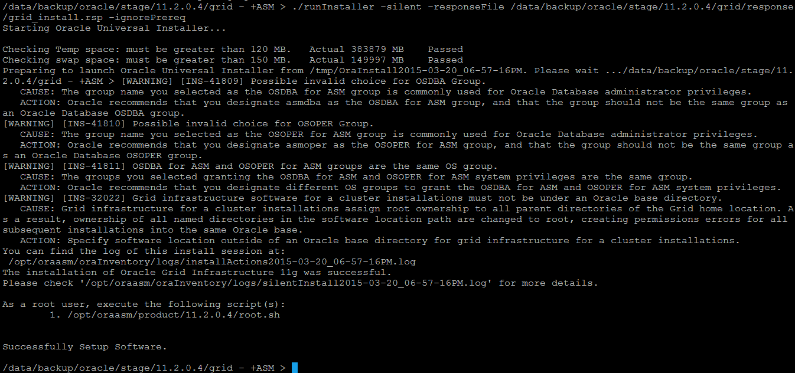

# Configure the CSS & OHAS services

As root

# $ /opt/oraasm/product/11.2.0.3/crs/install/roothas.pl -deconfig -force

# $ /opt/oraasm/product/11.2.0.4/crs/install/roothas.pl

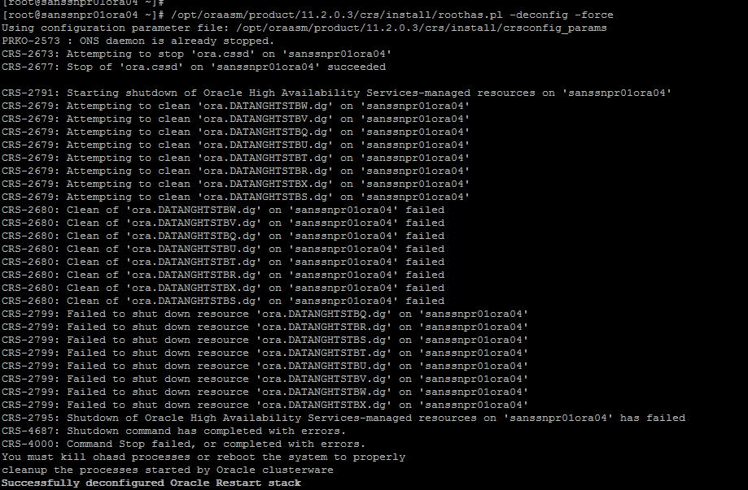

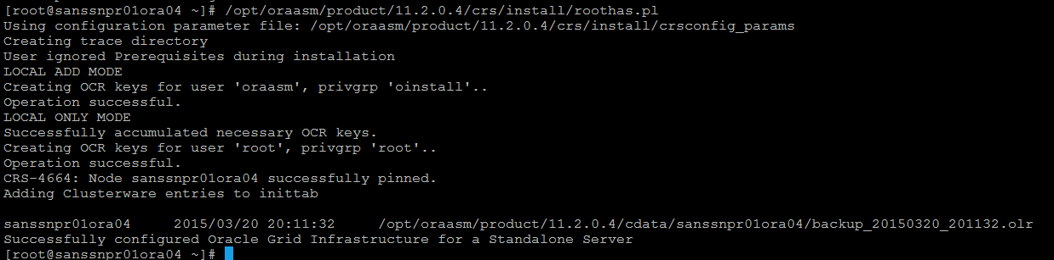

# Configure AUTO_START

As oraasm

$> /opt/oraasm/product/11.2.0.4/bin/crsctl modify resource "ora.cssd" -attr "AUTO_START=1"

$> /opt/oraasm/product/11.2.0.4/bin/crsctl modify resource "ora.diskmon" -attr "AUTO_START=1"



# Restart the OHAS stack

$> /opt/oraasm/product/11.2.0.4/bin/crsctl stop has

$> /opt/oraasm/product/11.2.0.4/bin/crsctl start has

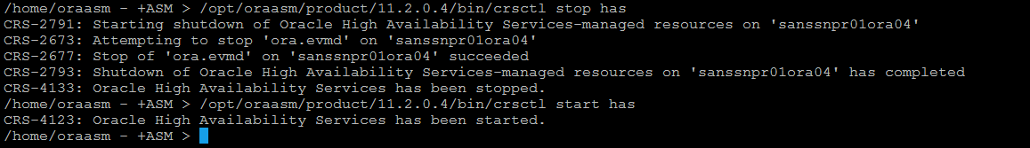

# Check the CSS & OHAS state

$> /opt/oraasm/product/11.2.0.4/bin/crsctl check has

$> /opt/oraasm/product/11.2.0.4/bin/crsctl check css

$> /opt/oraasm/product/11.2.0.4/bin/crsctl stat resource

$> /opt/oraasm/product/11.2.0.4/bin/crsctl stat res –t

Note: If the CSS & OHAS service did NOT start, then you will need to reboot the Linux box and check them again.

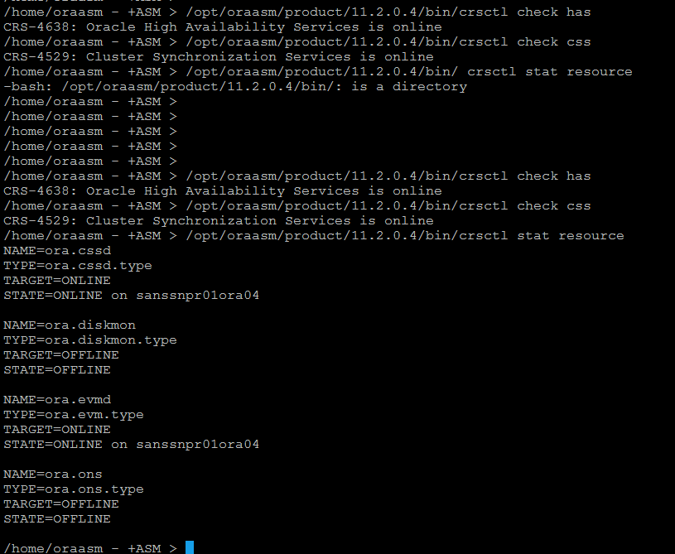

# Copy Old spfile to new GI Home



# Create pfile from spfile

# $> export ORACLE_SID=+ASM

$> /opt/oraasm/product/11.2.0.4/bin/sqlplus "/as sysasm"

SQL> create pfile='/opt/oraasm/product/11.2.0.4/dbs/init+ASM.ora' from spfile='/opt/oraasm/product/11.2.0.4/dbs/spfile+ASM.ora';

SQL> quit

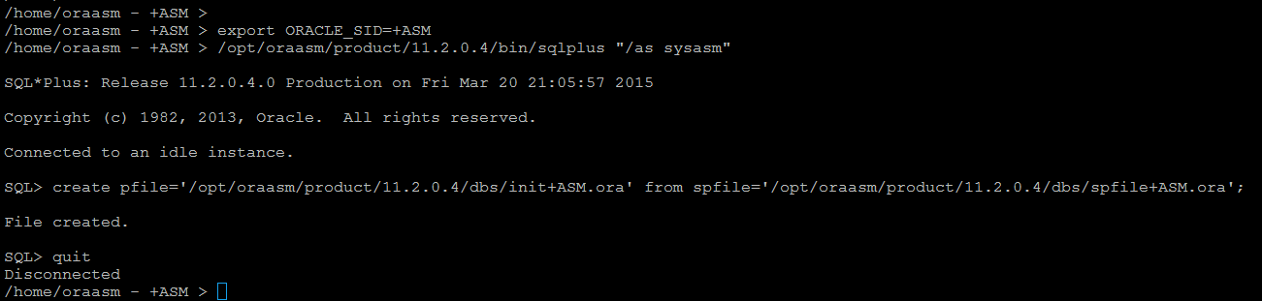

# Add ASM instance to cluster registry

$> /opt/oraasm/product/11.2.0.4/bin/srvctl add asm



# Enable ASM instance Auto Start

$> /opt/oraasm/product/11.2.0.4/bin/crsctl modify resource "ora.asm" -attr "AUTO_START=1"



# Make sure the disks are discovered by kfod

$> /opt/oraasm/product/11.2.0.4/bin/kfod asm_diskstring='ORCL:*' disks=all

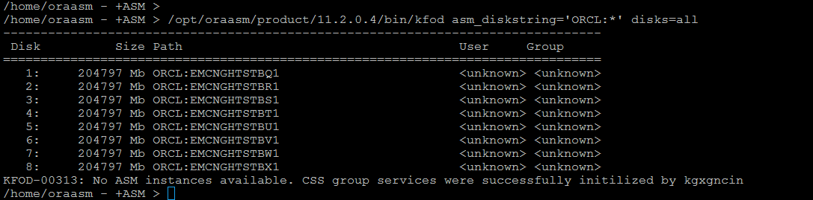

# Startup the ASM instance

$> export ORACLE_SID=+ASM

$> cd /opt/oraasm/product/11.2.0.4/dbs

$> /opt/oraasm/product/11.2.0.4/bin/sqlplus "/as sysasm"

SQL> startup pfile=init+ASM.ora

SQL> show parameter asm

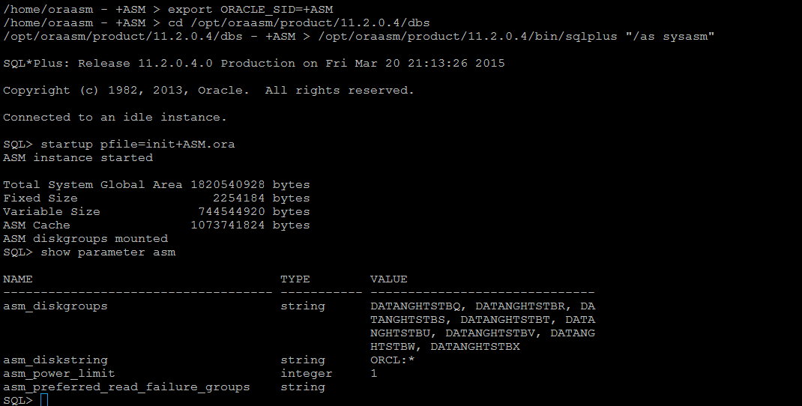

# Validate that the original diskgroup(s) were mounted

SQL> select name, state from v$asm_diskgroup;

SQL> quit

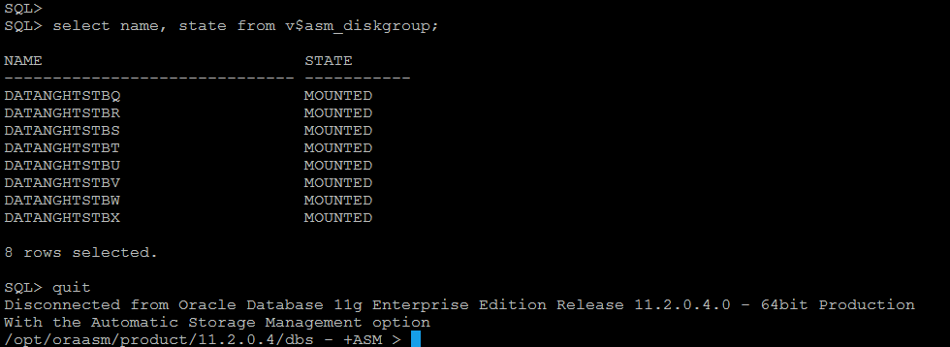

# Validate the OHAS (autostart) services

$> /opt/oraasm/product/11.2.0.4/bin/crsctl stop has

$> /opt/oraasm/product/11.2.0.4/bin/crsctl start has

$> /opt/oraasm/product/11.2.0.4/bin/crsctl stat res -t

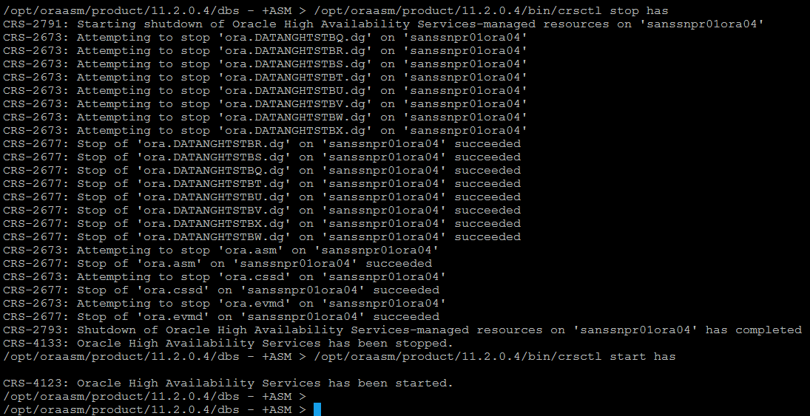

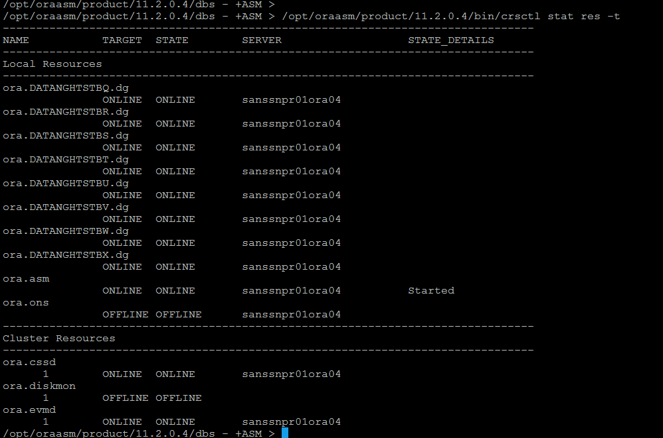

# Check the new HAS version

## Should be 11.2.0.4

$> /opt/oraasm/product/11.2.0.4/bin/crsctl query has releaseversion

$> /opt/oraasm/product/11.2.0.4/bin/crsctl query has softwareversion



# Modify /home/oraasm/asm.env

**Before**

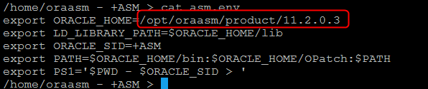

**After**

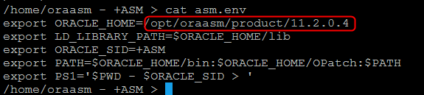

# Apply PSU 11.2.0.4.5 to ASM

## Upgrade OPatch

As root

# cd /opt/oraasm/product/11.2.0.4

# mv OPatch OPatch.bak

# cp /data/backup/oracle/stage/p6880880_112036_Linux-x86-64.zip .

# unzip p6880880_112036_Linux-x86-64.zip

# rm p6880880_112036_Linux-x86-64.zip

# chown -R oraasm:oinstall OPatch



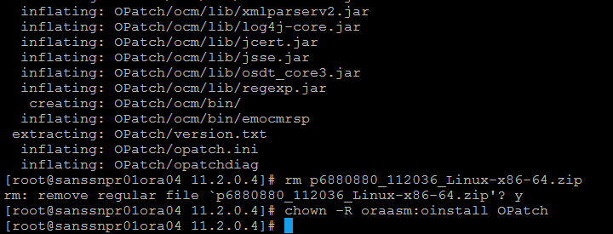

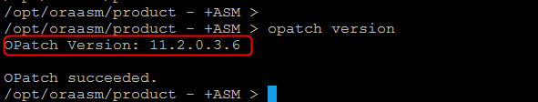

## Create OCM response file

As oraasm

Make sure ORACLE_HOME points to new GI Home.

$> echo $ORACLE_HOME



## Execute emocmrsp

$> $ORACLE_HOME/OPatch/ocm/bin/emocmrsp -no_banner -output /home/oraasm/ocm.rsp

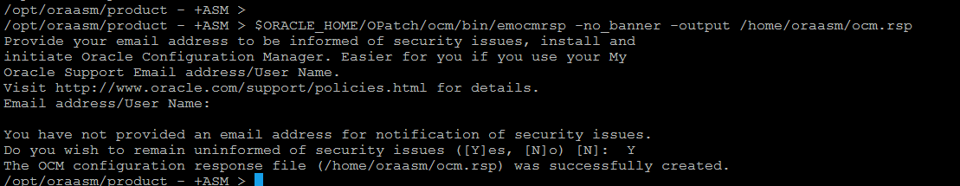

## Validate Oracle Inventory

$> $ORACLE_HOME/OPatch/opatch lsinventory -detail -oh $ORACLE_HOME

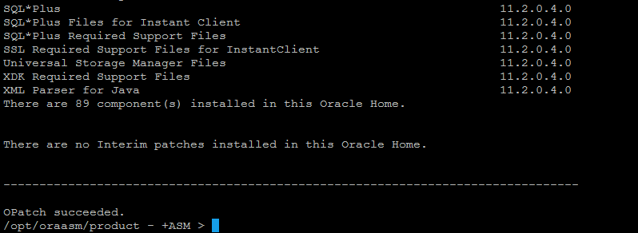

If this command succeeds, it lists the Oracle components that are installed in the home. Save the output so you have the status prior to the patch apply.

## Apply PSU 11.2.0.4.5 to ASM

# opatch auto /data/backup/oracle/stage/11.2.0.4/PSU.11.2.0.4.5/19955028 -ocmrf /home/oraasm/ocm.rsp

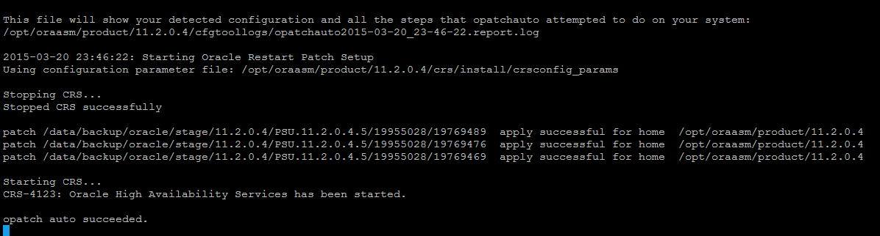

## Check the GI (OCW Oracle Clusterware) version for PSU 11.2.0.4.5

As oraasm

$> opatch lsinventory

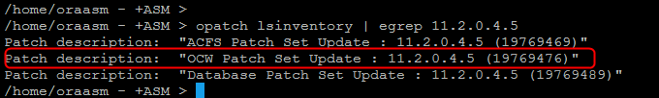

# Upgrade Database 11.2.0.3 to 11.2.0.4.5

Change the ownership on the software directory to the owner of the database to upgrade.

As oraasm

# cd /data/backup/oracle/

# chown -R oranghtstbq:oinstall stage

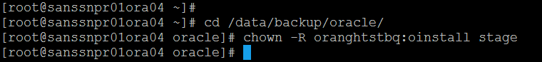

## Adjust oraInst.ora file

Before:

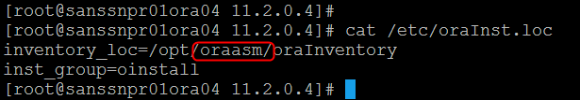

After:

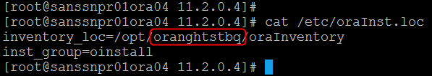

## Refresh old pfile initNGHTSTBQ.env from spfile

$> sqlplus / as sysdba

SQL> create pfile from spfile;

SQL> quit

$>

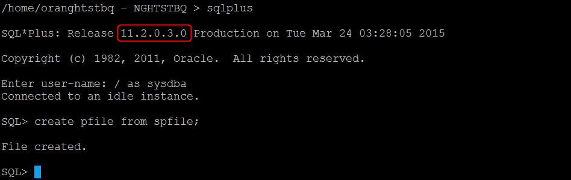

## Install 11.2.0.4 Database software into new folder

### Adjust inventory location

As root

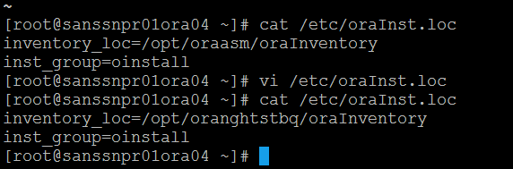

### Change owner of stage directory

Change directory to /data/backup/oracle and change the ownership of directory stage which holds Oracle binaries.

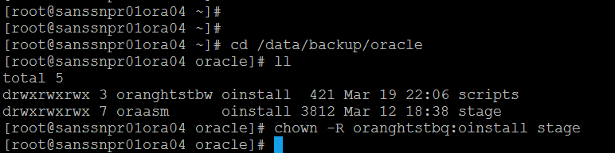

### Check software stage

Insure necessary binaries must have been already unzipped in “database” directory exists under /data/backup/oracle/stage/11.2.0.4.

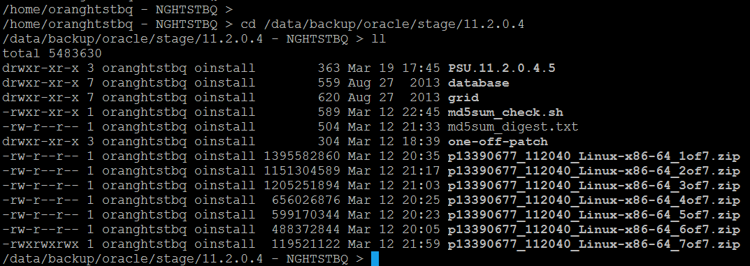

**Edit response file**

Change directory to /data/backup/oracle/stage/11.2.0.4/database/response and edit response file db_install.rsp.

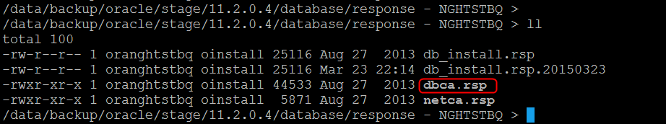

oracle.install.option=INSTALL_DB_SWONLY

ORACLE_HOSTNAME=sanssnpr01ora04.san.ssnsgs.net

UNIX_GROUP_NAME=oinstall

INVENTORY_LOCATION=/opt/oranghtstbq/oraInventory

ORACLE_HOME=/opt/oranghtstbq/product/11.2.0.4

ORACLE_BASE=/opt/oranghtstbq

oracle.install.db.InstallEdition=EE

oracle.install.db.DBA_GROUP=dba

oracle.install.db.OPER_GROUP=dba

SECURITY_UPDATES_VIA_MYORACLESUPPORT=false

DECLINE_SECURITY_UPDATES=true

### Create inventory and Oracle home directories

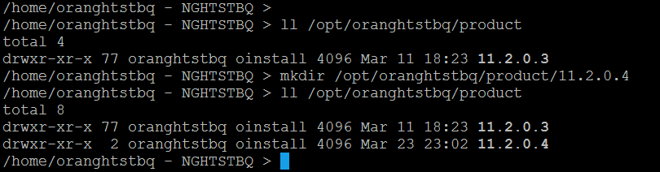

### Install Oracle in silent mode

Change directory to “/data/backup/oracle/stage/11.2.0.4/database” and run following command

./runInstaller -silent -responseFile /data/backup/oracle/stage/11.2.0.4/database/response/db_install.rsp

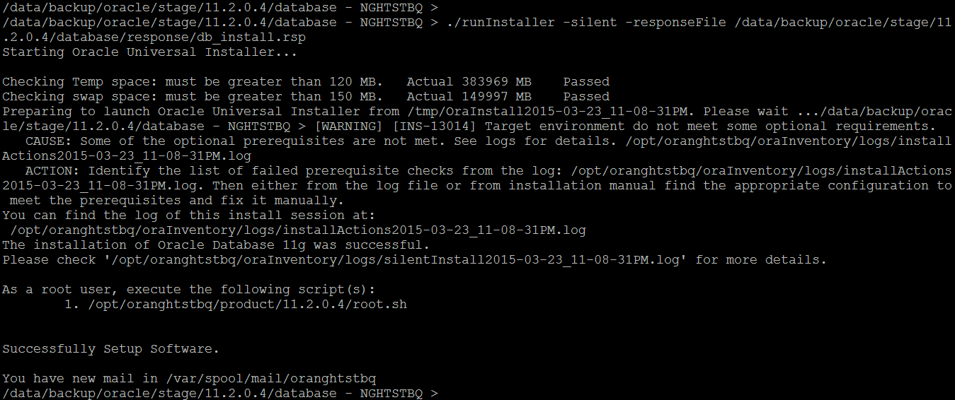

Check the log file and make sure no errors.

### Run root.sh

It will prompt for running root.sh. Login as root on a different window and run the root.sh script

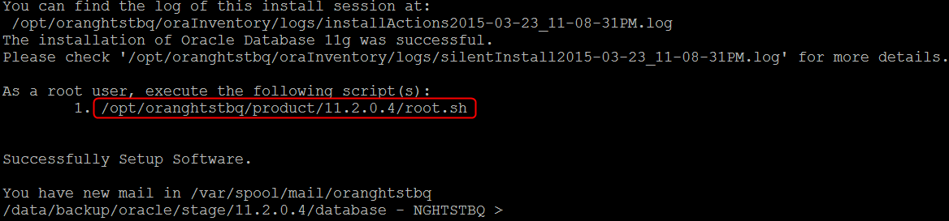

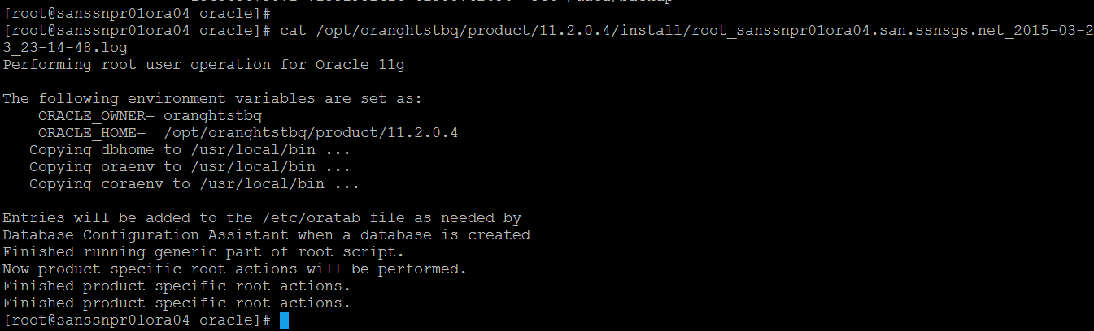

### Set-up environment file

Set-up environment file and test Oracle installation by logging in as sysdba.

Change to /home/oranghtstbq

copy nghtstbq.env to nghtstbq11204.env and edit ORACLE_HOME to reflect the new 11.2.0.4 Home.

$> cd ~

$> cp nghtstbq.env nghtstbq11204.env

$> vi nghtstbq11204.env

$>

Source the env file

$> . ~/nghtstbq11204.env

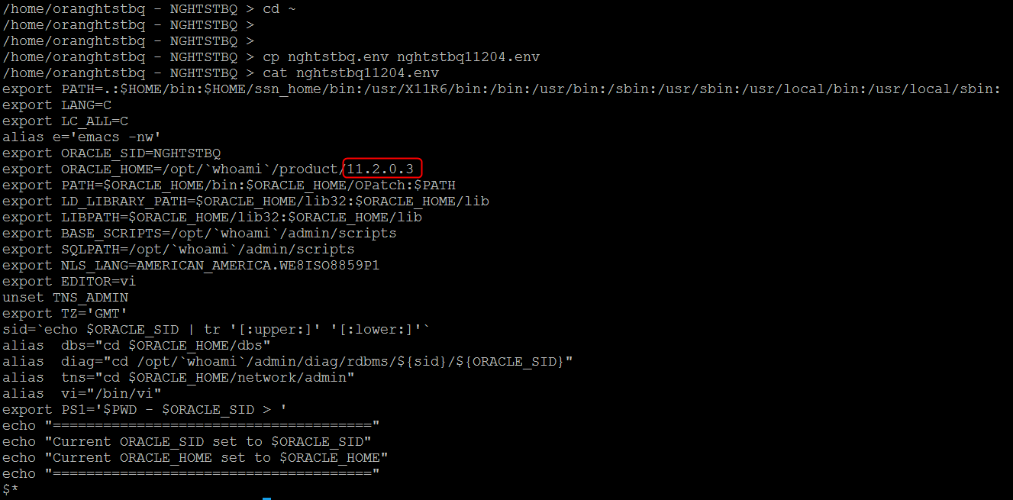

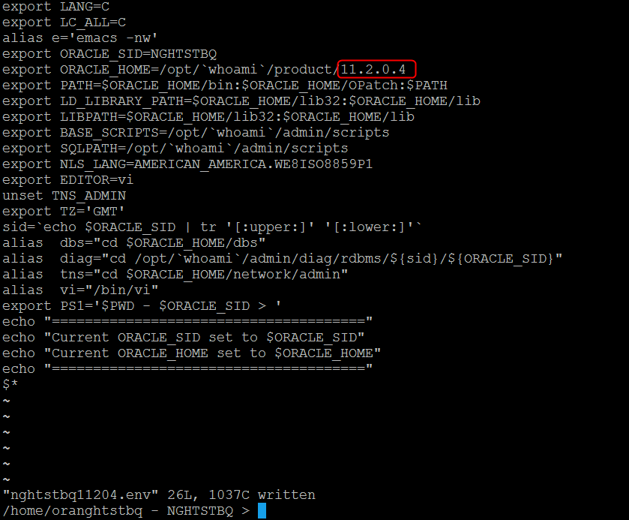

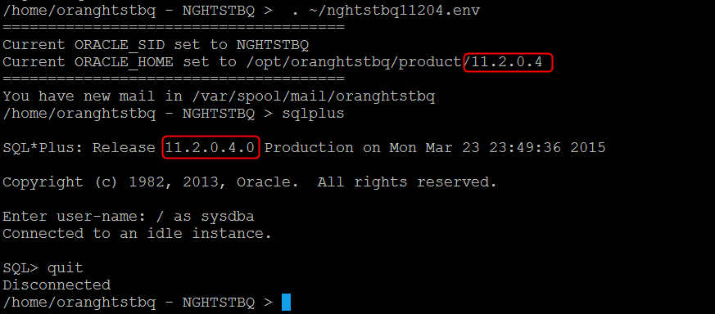

### Copy pfile to new $ORACLE_HOME/dbs directory.

$> cp /data/backup/oracle/stage/11.2.0.3/dbs/initNGHTSTBQ.ora /data/backup/oracle/stage/11.2.0.4/dbs

### Copy listener.ora and tnsnames.ora to new $ORACLE_HOME/network/admin directory.

$> cp /data/backup/oracle/stage/11.2.0.3/network/admin/listener.ora /data/backup/oracle/stage/11.2.0.4/network/admin

$> cp /data/backup/oracle/stage/11.2.0.3/network/admin/tnsnames.ora /data/backup/oracle/stage/11.2.0.4/network/admin

# Apply Oracle Patch Set Update 11.2.0.4.5

**Location of Oracle Binaries on Data Domain**

Oracle binaries for the patches are copied onto data domain in /data/backup/oracle/stage/11.2.0.4

/home/oranghtstbq - NGHTSTBQ > cd /data/backup/oracle/stage/11.2.0.4/

You have new mail in /var/spool/mail/oranghtstbq

/data/backup/oracle/stage/11.2.0.4 - NGHTSTBQ > ll

total 5483630

drwxr-xr-x 3 oranghtstbq oinstall 363 Mar 19 17:45 PSU.11.2.0.4.5

drwxr-xr-x 7 oranghtstbq oinstall 559 Aug 27 2013 database

drwxr-xr-x 7 oranghtstbq oinstall 620 Aug 27 2013 grid

-rwxr-xr-x 1 oranghtstbq oinstall 589 Mar 12 22:45 md5sum_check.sh

-rw-r--r-- 1 oranghtstbq oinstall 504 Mar 12 21:33 md5sum_digest.txt

drwxr-xr-x 3 oranghtstbq oinstall 304 Mar 12 18:39 one-off-patch

-rw-r--r-- 1 oranghtstbq oinstall 1395582860 Mar 12 20:35 p13390677_112040_Linux-x86-64_1of7.zip

-rw-r--r-- 1 oranghtstbq oinstall 1151304589 Mar 12 21:17 p13390677_112040_Linux-x86-64_2of7.zip

-rw-r--r-- 1 oranghtstbq oinstall 1205251894 Mar 12 21:03 p13390677_112040_Linux-x86-64_3of7.zip

-rw-r--r-- 1 oranghtstbq oinstall 656026876 Mar 12 20:25 p13390677_112040_Linux-x86-64_4of7.zip

-rw-r--r-- 1 oranghtstbq oinstall 599170344 Mar 12 20:23 p13390677_112040_Linux-x86-64_5of7.zip

-rw-r--r-- 1 oranghtstbq oinstall 488372844 Mar 12 20:05 p13390677_112040_Linux-x86-64_6of7.zip

-rwxrwxrwx 1 oranghtstbq oinstall 119521122 Mar 12 21:59 p13390677_112040_Linux-x86-64_7of7.zip

/data/backup/oracle/stage/11.2.0.4 - NGHTSTBQ >

**Backup Oracle inventory**

$> tar -cvf ./data/backup/NGHTSTBQ/oraInvNGHTSTBQ_20150323.tar

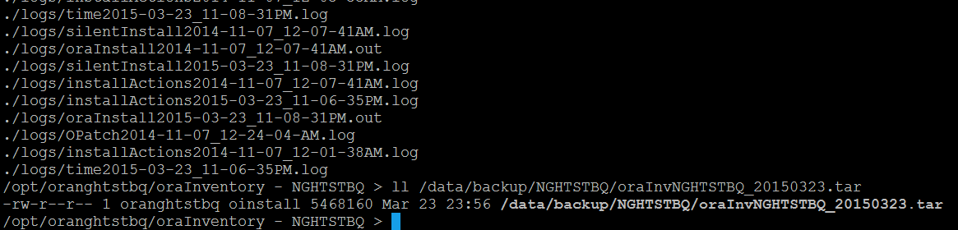

## Check and upgrade Opatch version

### Verify OPatch version

OPatch version should be at least 11.2.0.3.6 or later.

/home/oranghtstbq - NGHTSTBQ > export PATH=$ORACLE_HOME/OPatch:$PATH

/home/oranghtstbq - NGHTSTBQ > opatch version

Invoking OPatch 11.2.0.3.4

OPatch Version: 11.2.0.3.4

OPatch succeeded.

/home/oranghtstbq - NGHTSTBQ >

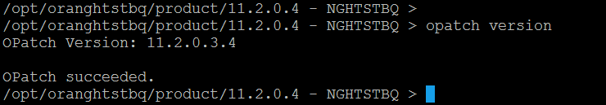

$> cp OPatch OPatch.bak

$> cp /data/backup/oracle/stage/p6880880_112036_Linux-x86-64.zip

$> unzip p6880880_112036_Linux-x86-64.zip



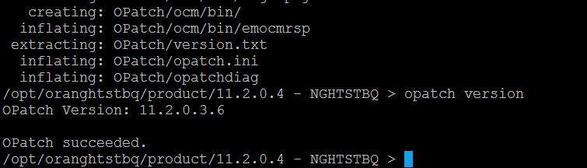

### Check patch prerequisites

cd /data/backup/oracle/stage/11.2.0.4/PSU.11.2.0.4.5/19955028/19769489

/data/backup/oracle/stage/11.2.0.4/PSU.11.2.0.4.5/19955028/19769489 - NGHTSTBQ > opatch prereq CheckConflictAgainstOHWithDetail -ph ./

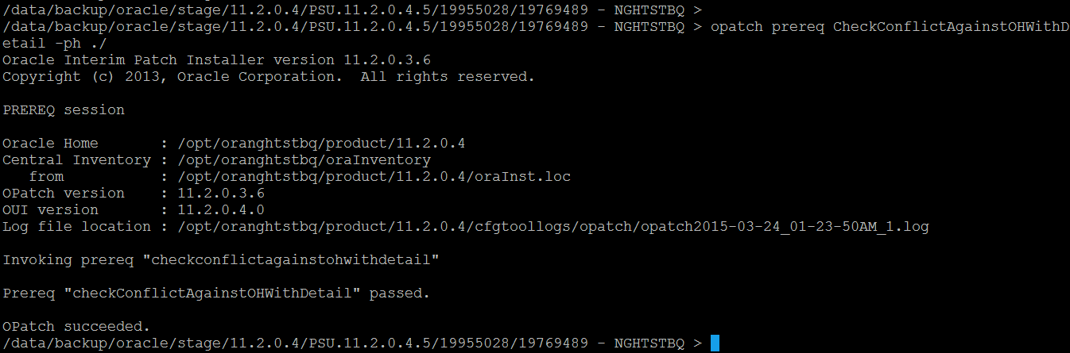

### Apply the PSU (Patch Set Update)

If using Oracle data guard make sure to patch both primary and standby.

/data/backup/oracle/stage/11.2.0.4/PSU.11.2.0.4.5/19955028/19769489 - NGHTSTBQ > opatch lsinventory

Oracle Interim Patch Installer version 11.2.0.3.6

Copyright (c) 2013, Oracle Corporation. All rights reserved.

Oracle Home : /opt/oranghtstbq/product/11.2.0.4

Central Inventory : /opt/oranghtstbq/oraInventory

from : /opt/oranghtstbq/product/11.2.0.4/oraInst.loc

OPatch version : 11.2.0.3.6

OUI version : 11.2.0.4.0

Log file location : /opt/oranghtstbq/product/11.2.0.4/cfgtoollogs/opatch/opatch2015-03-24_01-26-42AM_1.log

Lsinventory Output file location : /opt/oranghtstbq/product/11.2.0.4/cfgtoollogs/opatch/lsinv/lsinventory2015-03-24_01-26-42AM.txt

--------------------------------------------------------------------------------

Installed Top-level Products (1):

Oracle Database 11g 11.2.0.4.0

There are 1 product(s) installed in this Oracle Home.

There are no Interim patches installed in this Oracle Home.

--------------------------------------------------------------------------------

OPatch succeeded.

/data/backup/oracle/stage/11.2.0.4/PSU.11.2.0.4.5/19955028 - NGHTSTQ > opatch apply

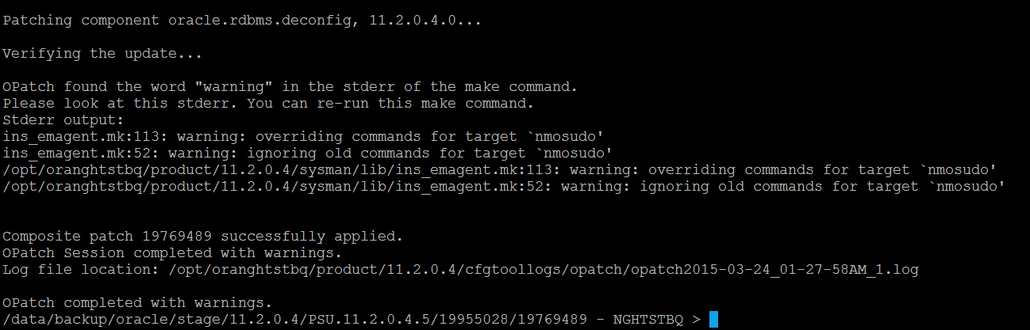

/data/backup/oracle/stage/11.2.0.4/PSU.11.2.0.4.5/19955028/19769489 - NGHTSTBQ > opatch lsinventory

Oracle Interim Patch Installer version 11.2.0.3.6

Copyright (c) 2013, Oracle Corporation. All rights reserved.

Oracle Home : /opt/oranghtstbq/product/11.2.0.4

Central Inventory : /opt/oranghtstbq/oraInventory

from : /opt/oranghtstbq/product/11.2.0.4/oraInst.loc

OPatch version : 11.2.0.3.6

OUI version : 11.2.0.4.0

Log file location : /opt/oranghtstbq/product/11.2.0.4/cfgtoollogs/opatch/opatch2015-03-24_01-36-44AM_1.log

Lsinventory Output file location : /opt/oranghtstbq/product/11.2.0.4/cfgtoollogs/opatch/lsinv/lsinventory2015-03-24_01-36-44AM.txt

--------------------------------------------------------------------------------

Installed Top-level Products (1):

Oracle Database 11g 11.2.0.4.0

There are 1 product(s) installed in this Oracle Home.

Interim patches (1) :

Patch 19769489 : applied on Tue Mar 24 01:28:52 GMT 2015

Unique Patch ID: 18236413

Patch description: "Database Patch Set Update : 11.2.0.4.5 (19769489)"

Created on 28 Dec 2014, 21:22:44 hrs PST8PDT

Sub-patch 19121551; "Database Patch Set Update : 11.2.0.4.4 (19121551)"

Sub-patch 18522509; "Database Patch Set Update : 11.2.0.4.3 (18522509)"

Sub-patch 18031668; "Database Patch Set Update : 11.2.0.4.2 (18031668)"

Sub-patch 17478514; "Database Patch Set Update : 11.2.0.4.1 (17478514)"

Bugs fixed:

17288409, 18273830, 17811429, 17205719, 19972566, 17922254, 17754782

17726838, 16934803, 13364795, 17311728, 17441661, 17284817, 13645875

16992075, 18199537, 16542886, 17446237, 14565184, 19972569, 17071721

17610798, 17449815, 17375354, 17397545, 19463897, 18230522, 13866822

16360112, 17982555, 17235750, 19769489, 17478514, 12905058, 18235390

14338435, 13944971, 18641451, 20142975, 16929165, 12747740, 17546973

14054676, 17088068, 18264060, 17042658, 17343514, 17016369, 14602788

19972568, 19680952, 18471685, 18508861, 14657740, 17332800, 19211724

13951456, 16315398, 19972564, 18744139, 17186905, 16850630, 18315328

17437634, 19049453, 18673304, 17883081, 19006849, 18641419, 17296856

18674024, 18262334, 17006183, 18277454, 16833527, 17232014, 16855292

10136473, 17705023, 17865671, 18554871, 19121551, 18334586, 19854503

19309466, 17551709, 17588480, 19827973, 17842825, 17344412, 18828868

18681862, 18554763, 17390160, 17025461, 13955826, 11883252, 13609098

18139690, 17501491, 17239687, 17299889, 17752121, 17602269, 19197175

18673325, 17313525, 18293054, 17242746, 19544839, 18964939, 17600719

18191164, 17571306, 18482502, 19466309, 17951233, 18094246, 19615136

17165204, 17011832, 17040527, 18098207, 16785708, 17477958, 17174582

16180763, 17465741, 16777840, 18522509, 17323222, 19463893, 16595641

12816846, 16875449, 16524926, 17237521, 18228645, 18282562, 17596908

17811438, 17811447, 18031668, 17184721, 16494615, 16912439, 18061914

17282229, 17545847, 18202441, 17082359, 19554106, 17614134, 13558557

17341326, 14034426, 17891946, 18339044, 19458377, 17716305, 17752995

16392068, 19271443, 17891943, 18092127, 17258090, 17767676, 17614227

17040764, 14106803, 17381384, 15913355, 18973907, 18356166, 18673342

14084247, 17389192, 17612828, 17006570, 13853126, 17721717, 17570240

18203837, 17390431, 14245531, 16043574, 16863422, 19727057, 17468141

17786518, 17912217, 16422541, 19972570, 17037130, 17267114, 18244962

18203838, 16198143, 16956380, 17478145, 14829250, 17394950, 18189036

18641461, 17835627, 17027426, 16268425, 18247991, 14458214, 19584068

18436307, 17265217, 13498382, 16692232, 17786278, 17227277, 16042673

16314254, 17443671, 16228604, 16837842, 17571039, 17393683, 16344544

17787259, 18009564, 20074391, 14354737, 15861775, 18135678, 18614015

16399083, 18018515, 17835048, 16472716, 17936109, 17050888, 17325413

14010183, 18747196, 17036973, 16613964, 17080436, 17761775, 16721594

18280813, 17302277, 16901385, 15979965, 15990359, 18203835, 17297939

17811456, 16731148, 17215560, 14133975, 17385178, 17586955, 18441944

16450169, 17655634, 9756271, 19730508, 17892268, 17648596, 16220077

16069901, 11733603, 16285691, 17587063, 16538760, 18180390, 17393915

17274537, 18096714, 17308789, 17238511, 18436647, 17824637, 14285317

19289642, 14764829, 18328509, 17622427, 16943711, 18306996, 17346671

18996843, 14852021, 17783588, 16618694, 18674047, 17672719, 12364061

17851160, 17546761

--------------------------------------------------------------------------------

OPatch succeeded.

# Apply the One Off Patch

$> cd /data/backup/oracle/stage/11.2.0.4/one-off-patch/18259031

$> opatch prereq CheckConflictAgainstOHWithDetail -ph ./

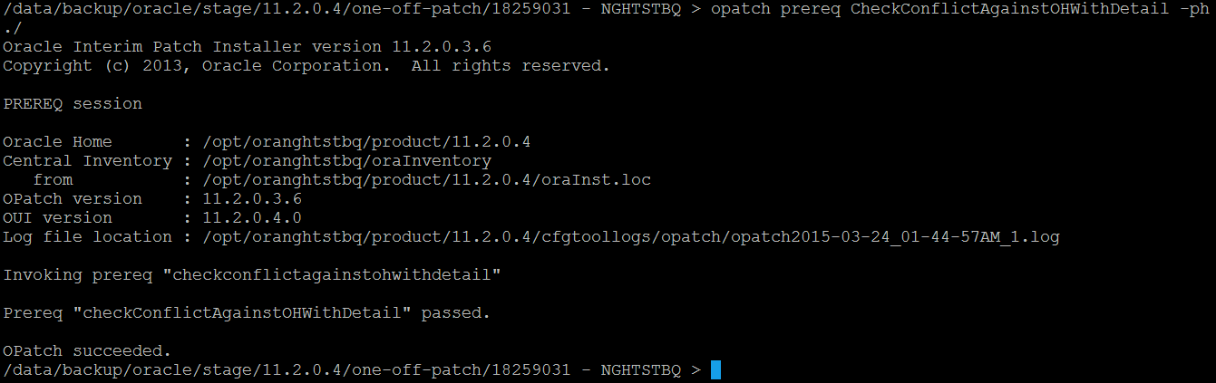

/data/backup/oracle/stage/11.2.0.4/one-off-patch/18259031 - NGHTSTBQ > opatch apply

Oracle Interim Patch Installer version 11.2.0.3.6

Copyright (c) 2013, Oracle Corporation. All rights reserved.

Oracle Home : /opt/oranghtstbq/product/11.2.0.4

Central Inventory : /opt/oranghtstbq/oraInventory

from : /opt/oranghtstbq/product/11.2.0.4/oraInst.loc

OPatch version : 11.2.0.3.6

OUI version : 11.2.0.4.0

Log file location : /opt/oranghtstbq/product/11.2.0.4/cfgtoollogs/opatch/18259031_Mar_24_2015_01_46_07/apply2015-03-24_01-46-07AM_1.log

Applying interim patch '18259031' to OH '/opt/oranghtstbq/product/11.2.0.4'

Verifying environment and performing prerequisite checks...

All checks passed.

Provide your email address to be informed of security issues, install and

initiate Oracle Configuration Manager. Easier for you if you use your My

Oracle Support Email address/User Name.

Visit http://www.oracle.com/support/policies.html for details.

Email address/User Name:

You have not provided an email address for notification of security issues.

Do you wish to remain uninformed of security issues ([Y]es, [N]o) [N]: y

Please shutdown Oracle instances running out of this ORACLE_HOME on the local system.

(Oracle Home = '/opt/oranghtstbq/product/11.2.0.4')

Is the local system ready for patching? [y|n] y

Is the local system ready for patching? [y|n]

y

User Responded with: Y

Backing up files...

Patching component oracle.rdbms, 11.2.0.4.0...

Verifying the update...

Patch 18259031 successfully applied

Log file location: /opt/oranghtstbq/product/11.2.0.4/cfgtoollogs/opatch/18259031_Mar_24_2015_01_46_07/apply2015-03-24_01-46-07AM_1.log

OPatch succeeded.

You have new mail in /var/spool/mail/oranghtstbq

/data/backup/oracle/stage/11.2.0.4/one-off-patch/18259031 - NGHTSTBQ >

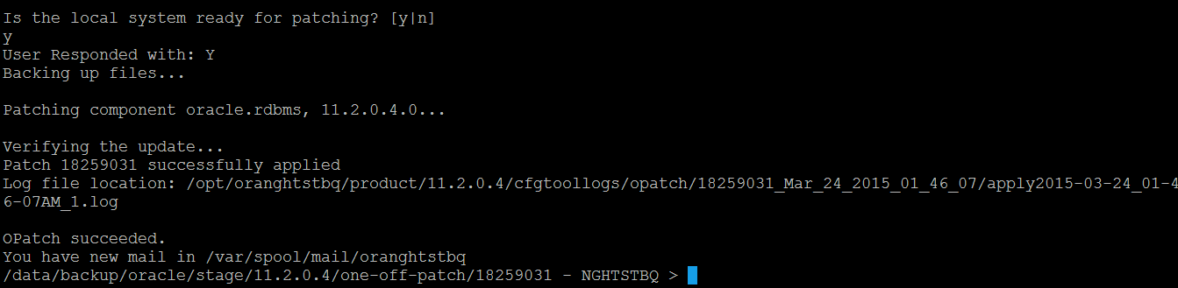

**\*\*\*\*\*\*\*\*\*\*\*\*\*\*\*\*\*\*\* From Jason \*\*\*\*\*\*\*\*\*\*\*\*\*\*\*\*\*\*\*\*\*\*\*\*\*\*\*\*\*\***

**Apply One off patch to RDBMS for ORA-600 Errors on top of PSU 11.2.0.4.5**

/data/backup/oracle/stage/p18259031_112045_Linux-x86-64.zip

**\*\*\*\*\*\*\*\*\*\*\*\*\*\*\*\*\*\*\* From Jason \*\*\*\*\*\*\*\*\*\*\*\*\*\*\*\*\*\*\*\*\*\*\*\*\*\*\*\*\*\***

# Upgrade Database

## Execute database upgrade

Change to the 11.2.0.4 ORACLE_HOME/rdbms/admin directory.

$> cd $ORACLE_HOME

$> sqlplus / as sysdba

SQL> STARTUP UPGRADE

SQL> SPOOL upgrade.log

SQL> @catupgrd.sql

## 2.5.2 Loading Modified SQL Files into the Database

cd $ORACLE_HOME/rdbms/admin

sqlplus / as sysdba

SQL> STARTUP

SQL> @catbundle.sql psu apply

SQL> QUIT

## Check PSU registration

SQL> SELECT * FROM dba_registry_history WHERE comments LIKE '%PSU 11.2.0.4.5%';

## Move new environment file into place.

$> cd

$> mv nghtstbq.env nghtstbq11203.env

$> cp nghtstbq11204.env nghtstbq.env

$>

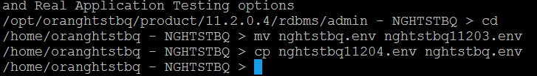

# Start Listener

Copy listener.ora file from old home /opt/oranghtstbq/product/11.2.0.3/network/admin/listener.ora to new home /opt/oranghtstbq/product/11.2.0.3/network/admin/listener.ora

$> cp /opt/oranghtstbq/product/11.2.0.3/network/admin/listener.ora /opt/oranghtstbq/product/11.2.0.3/network/admin

$> lsnrctl

LSNRCTL> set cu NGHTSTBQ_LISTENER

LSNRCTL> start

LSNRCTL> quit

$>

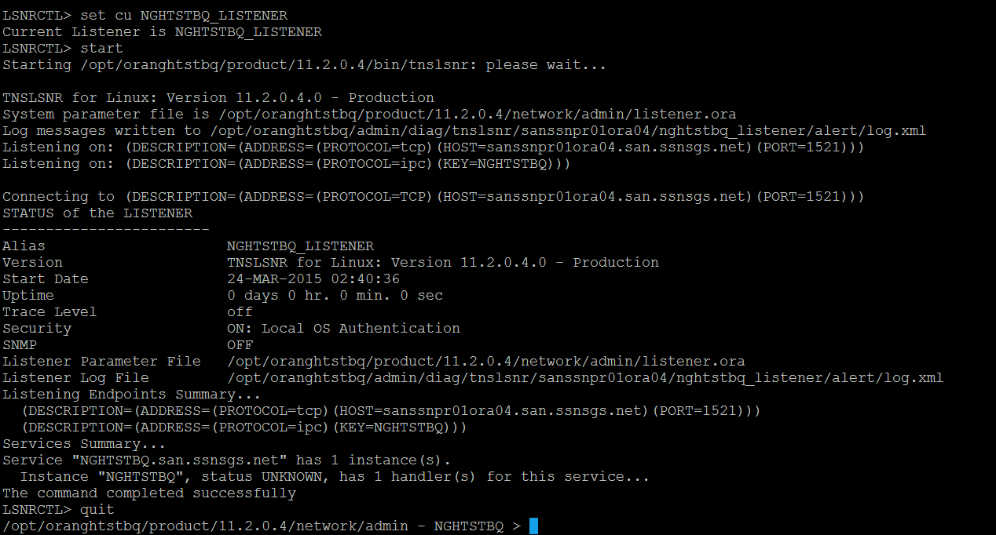

# Upgrade RMAN catalog

# Backup Catalog Database

/home/oranghtstbq/backups - NGHTSTBQ >

/home/oranghtstbq/backups - NGHTSTBQ > expdp \'sys/sys_gr1d@catsandb as sysdba\' directory=expdir schemas=rman dumpfile=exp_rman_032015.dmp logfile=exp_rman_032015.log

Export: Release 11.2.0.4.0 - Production on Tue Mar 24 03:03:35 2015

Copyright (c) 1982, 2011, Oracle and/or its affiliates. All rights reserved.

Connected to: Oracle Database 11g Enterprise Edition Release 11.2.0.3.0 - 64bit Production

With the Partitioning, Automatic Storage Management, OLAP, Data Mining

and Real Application Testing options

Starting "SYS"."SYS_EXPORT_SCHEMA_01": "sys/********@catsandb AS SYSDBA" directory=expdir schemas=rman dumpfile=exp_rman_032015.dmp logfile=exp_rman_032015.log

Estimate in progress using BLOCKS method...

Processing object type SCHEMA_EXPORT/TABLE/TABLE_DATA

Total estimation using BLOCKS method: 1.913 GB

Processing object type SCHEMA_EXPORT/USER

Processing object type SCHEMA_EXPORT/ROLE_GRANT

Processing object type SCHEMA_EXPORT/DEFAULT_ROLE

Processing object type SCHEMA_EXPORT/TABLESPACE_QUOTA

Processing object type SCHEMA_EXPORT/PRE_SCHEMA/PROCACT_SCHEMA

Processing object type SCHEMA_EXPORT/TYPE/TYPE_SPEC

Processing object type SCHEMA_EXPORT/SEQUENCE/SEQUENCE

Processing object type SCHEMA_EXPORT/SEQUENCE/GRANT/OWNER_GRANT/OBJECT_GRANT

Processing object type SCHEMA_EXPORT/TABLE/TABLE

# Execute RMAN catalog upgrade

/home/oranghtstbq/backups - NGHTSTBQ > rman target / catalog rman/catman@catsandb

Recovery Manager: Release 11.2.0.4.0 - Production on Tue Mar 24 03:18:04 2015

Copyright (c) 1982, 2011, Oracle and/or its affiliates. All rights reserved.

connected to target database: NGHTSTBQ (DBID=2734587750)

connected to recovery catalog database

PL/SQL package RMAN.DBMS_RCVCAT version 11.02.00.03 in RCVCAT database is not current

PL/SQL package RMAN.DBMS_RCVMAN version 11.02.00.03 in RCVCAT database is not current

RMAN> upgrade catalog;

recovery catalog owner is RMAN

enter UPGRADE CATALOG command again to confirm catalog upgrade

RMAN> upgrade catalog;

error creating node

RMAN-00571: ===========================================================

RMAN-00569: =============== ERROR MESSAGE STACK FOLLOWS ===============

RMAN-00571: ===========================================================

RMAN-06004: ORACLE error from recovery catalog database: ORA-00054: resource busy and acquire with NOWAIT specified or timeout expired

RMAN> upgrade catalog;

recovery catalog owner is RMAN

enter UPGRADE CATALOG command again to confirm catalog upgrade

RMAN> upgrade catalog;

recovery catalog upgraded to version 11.02.00.04

DBMS_RCVMAN package upgraded to version 11.02.00.04

DBMS_RCVCAT package upgraded to version 11.02.00.04

RMAN>

# Remove Old "11.2.0.3" Oracle Home

## Adjust /etc/oraInst.loc

Change Inventory location to /opt/oranghtstbq/oraInventory

As root

# vi /etc/oraInst.loc

# cat /etc/oraInst.log

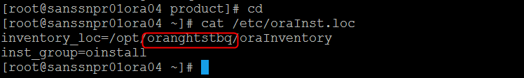

## Detach Old Oracle Home (11.2.0.3)

As oranghtstbq

$> cd /opt/oranghtstbq/product/11.2.0.4/oui/bin

$>./runInstaller -silent -detachHome -invPtrLoc /etc/oraInst.loc ORACLE_HOME="/opt/oranghtstbq/product/11.2.0.3"

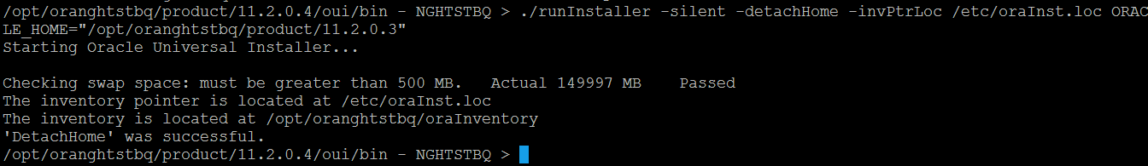

## Make sure there are no files open at /opt/oranghtstbq/product/11.2.0.3

$> lsof +D /opt/oranghtstbq/product/11.2.0.3



## Remove Directory /opt/oranghtstbq/product/11.2.0.3

$> rm -fR /opt/oranghtstbq/product/11.2.0.3

